**PIZZA SALES SQL QUERIES**

**A. KPI’s**

**1. Total Revenue:**

SELECT SUM(total_price) AS Total_Revenue FROM pizza_sales;

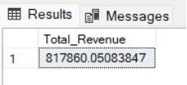

**2. Average Order Value**

SELECT (SUM(total_price) / COUNT(DISTINCT order_id)) AS Avg_order_Value FROM pizza_sales

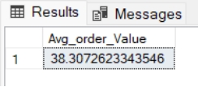

**3. Total Pizzas Sold**

SELECT SUM(quantity) AS Total_pizza_sold FROM pizza_sales

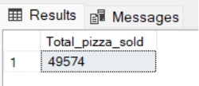

**4. Total Orders**

SELECT COUNT(DISTINCT order_id) AS Total_Orders FROM pizza_sales

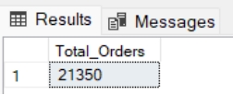

**5. Average Pizzas Per Order**

SELECT CAST(CAST(SUM(quantity) AS DECIMAL(10,2)) / CAST(COUNT(DISTINCT order_id) AS DECIMAL(10,2)) AS DECIMAL(10,2))AS Avg_Pizzas_per_order FROM pizza_sales

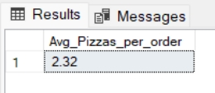

- IF YOU WANT ENTIRE DECIMAL VALUE THEN REMOVE THE FIRST CAST FROM THE SYNTAX.

**B. Daily Trend for Total Orders**SELECT DATENAME(DW, order_date) AS order_day, COUNT(DISTINCT order_id) AS total_orders FROM pizza_salesGROUP BY DATENAME(DW, order_date)

**Output:**

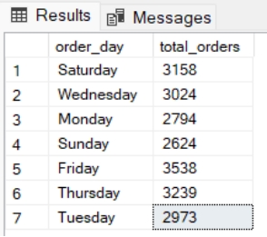

**C. Monthly Trend for Orders**

select DATENAME(MONTH, order_date) as Month_Name, COUNT(DISTINCT order_id) as Total_Orders from pizza_sales GROUP BY DATENAME(MONTH, order_date)

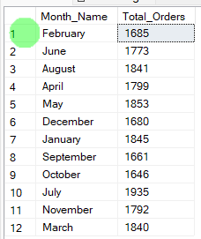**O/P**

USE SYNTAX: SELECT DATENAME(MONTH, order_date) AS Month_Name, COUNT(DISTINCT order_id) FROM pizza_sales GROUP BY DATENAME(MONTH, order_date) ORDER BY Total_Orders DESC IF YOU WANT OUTPUT IN DESCENDING ORDER

**D. % of Sales by Pizza Category**

SELECT pizza_category, CAST(SUM(total_price) AS DECIMAL(10,2)) as total_revenue, CAST(SUM(total_price) * 100 / (SELECT SUM(total_price) from pizza_sales) AS DECIMAL(10,2)) AS PCT FROM pizza_sales GROUP BY pizza_category

**Output:**

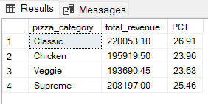

**E. % of Sales by Pizza Size**

SELECT pizza_size, CAST(SUM(total_price) AS DECIMAL(10,2)) as total_revenue, CAST(SUM(total_price) * 100 / (SELECT SUM(total_price) from pizza_sales) AS DECIMAL(10,2)) AS PCT FROM pizza_sales GROUP BY pizza_size ORDER BY pizza_size

**Output:** 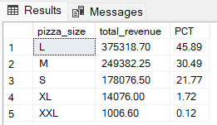

**F. Total Pizzas Sold by Pizza Category**

SELECT pizza_category, SUM(quantity) as Total_Quantity_Sold FROM pizza_sales WHERE MONTH(order_date) = 2 GROUP BY pizza_category ORDER BY Total_Quantity_Sold DESC

**Output:**

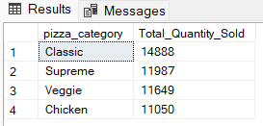

**G. Top 5 Pizzas by Revenue**

SELECT Top 5 pizza_name, SUM(total_price) AS Total_Revenue FROM pizza_sales GROUP BY pizza_name ORDER BY Total_Revenue DESC

**Output:**

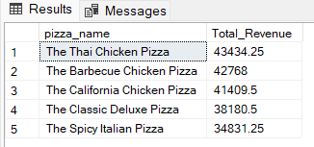

**H. Bottom 5 Pizzas by Revenue**

SELECT Top 5 pizza_name, SUM(total_price) AS Total_Revenue FROM pizza_sales GROUP BY pizza_name ORDER BY Total_Revenue ASC

- TO GET BOTTOM 5 TOP PIZZAS EITHER REMOVE DESC OR USE ASC

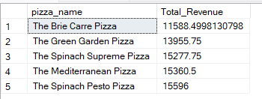

**I. Top 5 Pizzas by Quantity**

SELECT Top 5 pizza_name, SUM(quantity) AS Total_Pizza_Sold FROM pizza_sales GROUP BY pizza_name ORDER BY Total_Pizza_Sold DESC

**Output:**

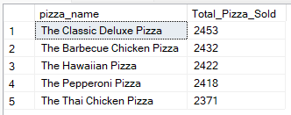

**J. Bottom 5 Pizzas by Quantity**

SELECT TOP 5 pizza_name, SUM(quantity) AS Total_Pizza_Sold FROM pizza_sales GROUP BY pizza_name ORDER BY Total_Pizza_Sold ASC

**Output:**

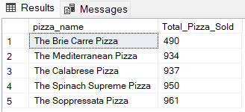

**K. Top 5 Pizzas by Total Orders**

SELECT Top 5 pizza_name, COUNT(DISTINCT order_id) AS Total_Orders FROM pizza_sales GROUP BY pizza_name ORDER BY Total_Orders DESC

**Output:**

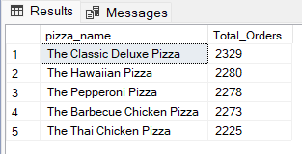

**L. Bottom 5 Pizzas by Total Orders**

SELECT Top 5 pizza_name, COUNT(DISTINCT order_id) AS Total_Orders FROM pizza_sales GROUP BY pizza_name ORDER BY Total_Orders ASC

**Output:**

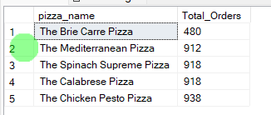

**NOTE:**

If you want to apply the pizza_category or pizza_size filters to the above queries you can use WHERE clause. Follow some of below examples

SELECT Top 5 pizza_name, COUNT(DISTINCT order_id) AS Total_Orders FROM pizza_sales WHERE pizza_category = 'Classic' GROUP BY pizza_name ORDER BY Total_Orders ASC